System and Software Architecture Description (SSAD)

LEMA Pilot School Integrated Scheduling System

Team No. 12

Name | Primary Role | Secondary Role
David Wiggins | Project Manager | Developer
Aakash Shah | Prototyper | Developer
Kushalpreet Kaur | Developer | Developer
Thammanoon Kawinfruangfukul | Tester | Developer
Eunyoung Hwang | Architect | Developer
Louis Demaria | IIV&V | Developer
Mark Villanueva | QFP | Developer
Sangik Park | Developer | Developer

04/27/2012

Version History
Date | Author | Version | Changes made | Rationale
10/12/11 | E.H. | 1.0 | - Introduction & System Analysis | - Initial draft for LEMA Pilot School Integrated Scheduling System v1.0
10/14/11 | E.H. | 1.1 | - Fix 1.2 and change APSCS term into a scheduler on the diagrams and tables | - Correct bugs detected from IIV&V personnel through Bugzilla
10/17/11 | E.H. | 2.0 | - Edit diagrams and add more use cases specification for 2.1.System Analysis Overview | - Correct diagram and pre-conditions for the process description according to the TA’s comment
10/21/11 | E.H. | 2.1 | - Correct diagrams on the System Analysis | - After getting comments from FCR ARB presentation
10/24/11 | E.H. | 3.0 | - Correct diagrams on the system analysis, especially the integration part with the external system, the LEMA Integrated Family Accountability System | - After the meeting with the other team from CSCI577 developing Family Accountability System of the same organization as us, LEMA pilot school
11/21/11 | E.H | 3.1 | - Add Technology-specific system design and Architectural styles, patterns and frameworks | - Draft DC Package for LEMA Integrated Scheduling System
11/29/11 | E.H | 3.2 | - Add a couple of sequence diagram and class diagram | - Prepare for DCR ARB session
12/05/11 | E.H | 3.3 | - Correct a couple of sequence diagrams and 4. Architectural styles, patterns and frameworks | - After the DCR ARB session, it is the final package for the 577a
02/05/12 | E.H. | 4.0 | - Updated ADO.NET framework into Symfony on diagrams | - Updating for the Draft Rebaselined DC Package
02/09/12 | E.H | 4.1 | - Corrected bugs reported on Bugzilla and updated diagrams | - Updating before Rebaselined DCR ARB
02/15/12 | E.H | 4.2 | - Detailed artifacts and information diagram | - Updating for the Rebaselined DC Package
03/26/12 | E.H | 5.0 | - Updated some use-cases and artifacts and information diagram | - Updating after getting comment from TA and for the first Initial Operational Capability Package
04/16/12 | E.H | 6.0 | - Updated overall reflecting current development status | - Updating before Code Review session
04/18/12 | EH, TK | 6.1 | - Updated diagrams and use case descriptions | - Refining for Code Review session
4/27/12 | EH | 6.2 | - Changed data implementation part from Symfony to MySQL connector as a stereotype for diagrams. | - After Code review, reflected comments

Table of Contents
System and Software Architecture Description (SSAD) i
Version History ii
Table of Contents iii
Table of Tables iv
Table of Figures vii
1. Introduction 1
1.1 Purpose of the SSAD 1
1.2 Status of the SSAD 1
2. System Analysis 2
2.1 System Analysis Overview 2
2.1.1 System Context 2
2.1.2 Artifacts & Information 4
2.1.3 Behavior 6
2.1.4 Modes of Operation 24
2.2 System Analysis Rationale 24
3. Technology-Specific System Design 26
3.1 Design Overview 26
3.1.1 System Structure 26
3.1.2 Design Courses 30
3.1.3 Process Realization 33
3.2 Design Rationale 36
4. Architectural Styles, Patterns and Frameworks 37

Table of Tables
Table 1: Actors Summary 3
Table 2: Artifacts and Information Summary 4
Table 3: Process Description - authenticate 6
Table 4: Typical Course of Action – authenticate: successful 7
Table 5: Alternate Course of Action – authenticate: failure 7
Table 6: Exceptional Course of Action – authenticate: failure to get a response from the external system 8
Table 7: Process Description – import district course list 8
Table 8: Typical Course of Action - import district course list 8
Table 9: Exceptional Course of Action – import district course list: invalid file type 9
Table 10: Process Description – view district course list 9
Table 11: Typical Course of Action - view district course list 9
Table 12: Process Description – input course detail 9
Table 13: Typical Course of Action - input course detail 10
Table 14: Exceptional Course of Action - input course detail : did not input course id or name 10
Table 15: Process Description – input course detail 10
Table 16: Typical Course of Action - input course detail 10
Table 17: Exceptional Course of Action - input course detail: did not input course name 11
Table 18: Process Description – set current semester course 11
Table 19: Typical Course of Action – set current semester course 11
Table 20: Process Description – set constraints 12
Table 21: Typical Course of Action - set constraints 12
Table 22: Alternate Course of Action - set constraints 12
Table 23: Process Description – generate course section 12
Table 24: Typical Course of Action - generate course section 13
Table 25: Alternate Course of Action - generate course section 13
Table 26: Process Description – view registered students 13
Table 27: Typical Course of Action - view registered students 14
Table 28: Exceptional Course of Action – view registered students: failure to get a response from the external system 14
Table 29: Process Description - input course preference 14
Table 30: Typical Course of Action - input course preference 14
Table 31: Alternate Course of Action - input course preference 15
Table 32: Exceptional Course of Action – input course preference: failure to get a response from the external system 15
Table 33: Process Description - update course preference 15
Table 34: Typical Course of Action - update course preference 16
Table 35: Exceptional Course of Action – update course preference: failure to get a response from the external system 16
Table 36: Process Description - approve course preference 16
Table 37: Typical Course of Action - approve course preference 17
Table 38: Alternate Course of Action – approve course preference 17
Table 39: Process Description - assign teacher to course 17
Table 40: Typical Course of Action – update teacher course 18
Table 41: Alternate Course of Action – update teacher course 18
Table 42: Process Description - export activity information 18
Table 43: Typical Course of Action - export activity information 18
Table 44: Process Description – import final schedule 19
Table 45: Typical Course of Action – import final schedule 19
Table 46: Alternative Course of Action – import final schedule 19
Table 47: Exceptional Course of Action – import final schedule: failure to import csv file 20
Table 48: Process Description – view final student schedule 20
Table 49: Typical Course of Action - view final student schedule 20
Table 50: Exceptional Course of Action – input course preference: failure to get a response from the external system 20
Table 51: Process Description – view final teacher schedule 21
Table 52: Typical Course of Action - view final teacher schedule 21
Table 53: Exceptional Course of Action – input course preference: failure to get a response from the external system 21
Table 54: Process Description – view enrolled students 21
Table 55: Typical Course of Action - view enrolled students 22
Table 56: Exceptional Course of Action – view enrolled students: failure to get a response from the external system 22
Table 57: Process Description – view student progress 22
Table 58: Typical Course of Action – view student progress 23
Table 59: Process Description - assign counselor 23
Table 60: Typical Course of Action - input counselor data 23
Table 61: Hardware Component Description 28
Table 62: Software Component Description 28
Table 63: Integration with the external system class diagram Description 30
Table 64: student course preference class diagram Description 31
Table 65: Export Activity Info & Import Final Schedule Class Diagram Description 32
Table 66: Architectural Styles, Patterns, and Frameworks 37

Table of Figures
Figure 1: System Context Diagram 2
Figure 2: Artifacts and Information Diagram 4
Figure 3: Use-case Diagram 6
Figure 4: Hardware Component Course Diagram 26
Figure 5: Software Component Course Diagram 27
Figure 6: Deployment Diagram 28
Figure 7: Integration with the external system Class Diagram 30
Figure 8: student course preference Class Diagram 31
Figure 9: Export Activity Info & Import Final Schedule Class Diagram 32
Figure 11: Authenticate Sequence Diagram 33
Figure 12: Student Course Preference Sequence Diagram 34
Figure 13: Export Activity Information Sequence Diagram 35
Figure 14: Import Student Final Schedule Sequence Diagram 35

Introduction

Purpose of the SSAD

The purpose of the System and Software Architecture Description (SSAD) is to document the object-oriented analysis and design of the system being developed. The developer uses the SSAD as reference to the system architecture and it is to help the maintainer and clients to understand the structure of the system after the proposed system is delivered.

Status of the SSAD

This document currently contains all the parts for System and Software Architecture Description of the LEMA Integrated Scheduling System. This version is revised after the Code Review session reflecting the 577b staff and it is part of IOC second set with overall the design part for synchronization between development and architecture design.

System Analysis

System Analysis Overview
The main purpose of the LEMA Pilot School Integrated Scheduling System is to enhance the performance for optimal course scheduling. The LEMA Integrated Scheduling system gets course preference input directly from the student and helps a counselor to review students’ preference information and confirm them. The system also provides with administrator's course input and teacher course allocation. The system’s main feature is to take the constraints defined by LAUSD norms or LEMA disciplines and to produce optimal scheduling based on those constraints and the data of students’ course register and teacher capacity. Furthermore, students are able to track their progresses while inputting course preference. Students and teacher finally can view their final schedule through the website.

System Context
Figure 1: System Context Diagram
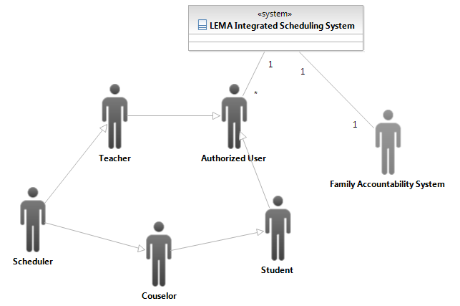

Table 1: Actors Summary
Actor | Description | Responsibilities
Authorized user | Users representing the general user who can be authorized by the system | - Log in and out of the system
student | Users who register courses for the next semester and track their progresses during semester | - Input and update course preference  - View student’s final schedule  - View their progress
teacher | Users who register their teaching capability of courses and follow course schedule | - View teacher’s final schedule  - View enrolled students
counselor | users reviewing each students registered course preference, checking whether student registered proper courses, and finalizing them | - View submitted students’ course preference  - Modify them if needed  - Approve students’ courses preference
Scheduler | A person assigning courses to teachers and setting constraints for scheduling | - Assign teachers to ccourses  - Input and update course information  - Import district course list  - Export teacher, course and activity information  - Import the final schedule into our database
LEMA Integrated Family Accountability System | A separate LEMA pilot school system, being built by another CSCI577 team, with which the LEMA Integrated Scheduling System | - Provide each user's authentication information to our system  - Provide faculty and student basic information via REST

Artifacts & Information

Figure 2: Artifacts and Information Diagram
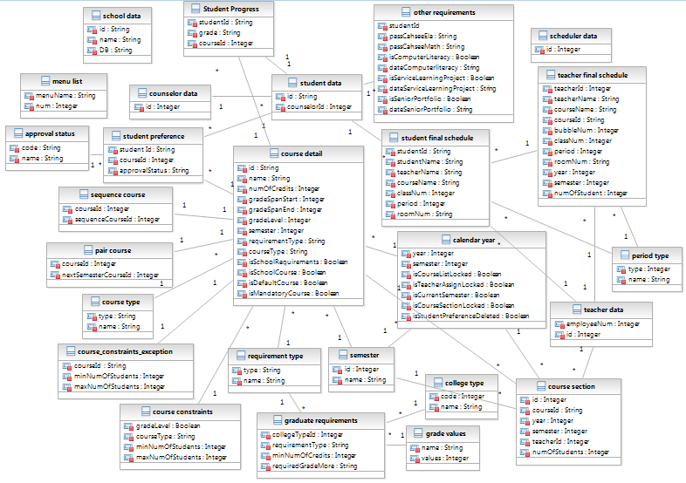
Table 2: Artifacts and Information Summary
Artifact | Purpose
ATF-1: counselor data | Contains a counselor id from the Accountability System
ATF-2: student data | Contains student id from the Accountability System
ATP-3: teacher data | Contains teacher id from the Accountability System
ATP-4: scheduler data | Contains scheduler id as an administrator from the Accountability System
ATF-5: student course preference | Contains student’s course preference information which student entered from the course preference form. However, the final schedule for each student has nothing to be related with the student preference because the final schedule is imported by the scheduler from the Columbia system.
ATP-6: course detail | Contains course detail with course id, name, and number of credits etc., which a scheduler entered from the course detail form
ATP-7: other requirements | Contains requirement information to graduate highschool
ATP-8: pair course | Contains current semester’s course id and the next semester’s course id
ATP-9: course type | Contains name and code of the course type such as mandatory or elective
ATP-10: course constraints | Contains the information about what grade level and what type of course needs how many numbers of students as minimum and maximum.
ATP-11: course section | Contains the course section information which is calculated by the system according to the class constraints. For example, when there are many students over maximum number of that course, the course can have more than one section. This section is formation is to feed the scheduling COTS as an activity data which contains the mapping of the teacher and course.
ATF-12: student final schedule | Contains student and course data created by the .CSV file format final schedule from the Columbia system
ATF-13: student progress | Contains student’s course and its grade information to track student’s progress
ATF-14: requirement type | Contains requirement type(A to G) code and name
ATF-15: sequence course | Contains course need to be scheduled side by side on the periods
ATF-16: menu list | Contains the menu(use case) list which the Scheduling System provides
ATF-17: graduate requirements | Contains graduate requirements categories, requirement type(A to G), minimum number of credits for each requirement type and required grade to graduate or to go to certain type of college or university
ATF-18:grade values | Contains grades and its values in order to weigh the value of the grades showing grade A is the higher one compared with the grade C
ATF-19:college type | Contains the name and code of the graduate requirement categories for the student progress tracking such as high school graduation, university of California, or community college
ATF-20:5calendar year | Contains year and semester information which is entered beginning of the course management
ATF-21: school data | Contains school code and database name for allowing only that school to access the specific database
ATF-22: Semester | Contains semester id and name
ATF-23: Approval status | Contains approval status code and name such as pending, denial, or approved for student’s course preference
ATF-24: Period type | Contains period type from 1 to 10 including club and advisory period
ATF-25: Teacher final schedule | Contains teachers final schedule which will allow a teacher to view their final schedule and this data come from School system (Columbia) as csv file format
ATF-26: Course constraints exception | Contains min and max number of students for specific courses as exceptions from general course constraints table

Behavior
Figure 3: Use-case Diagram
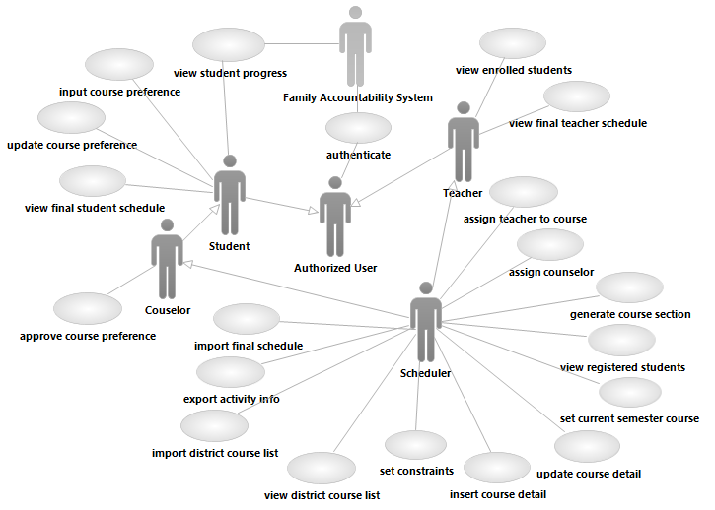

Authentication

Authenticate
Table 3: Process Description - authenticate
Identifier | UC-1: authenticate
Purpose | Authenticate and login user
Requirements | SR-3 Authentication to the system
Development Risks | Integration to get each user's authentication information from the external system which is LEMA Integrated Family Accountability System(FAS)
Pre-conditions | The system database is properly initialized
Post-conditions | If user is authorized, the user is able to access to appropriate functionality depending on the type of the user and the user’s session is generated; otherwise, the user is denied to access to the system.

Table 4: Typical Course of Action – authenticate: successful
Seq# | Actor’s Action | System’s Response
1 | [user] Inputs user name and password
2 | [user]Clicks "LEMA Scheduling System"
3 |  | Send user name and encrypted password to Family Accountability System
4 | [Family Accountability System]  return authentication result
5 |  | Check if the id exists in database and if not insert id into the user table
6 |  | Request the user's permission menu list which is accessible to the user type
7 | [Family Accountability System] return the list of the permission menu for that type of the user
8 |  | Compare the user's menu list from the Family Accountability System with each name at the menu list table from the database
9 |  | Display the verified menu list on the homepage of the Scheduling System
After the user login to the system, every page needs to get the list of the permission menu from Family Accountability System using REST (step 5-6 on table 4).
Table 5: Alternate Course of Action – authenticate: failure
Seq# | Actor’s Action | System’s Response
1-4 | Refer to typical course of action
5 |  | If the login status is fail, redirect to the login page with the error message (unauthorized user)

Table 6: Exceptional Course of Action – authenticate: failure to get a response from the external system
Seq# | Actor’s Action | System’s Response
1-3 | Refer to typical course of action
4 |  | Display “No response from the Accountability system” message
5 | Click ok button
6 |  | Redirects the user to the previous page

Course management

Import district course list
Table 7: Process Description – import district course list
Identifier | UC-2: import district course list
Purpose | Import district course list to the database
Requirements | CR-2 Lock in certain classes
Development Risks | none
Pre-conditions | The scheduler have the district course list file
Post-conditions | District course list saved into database
Table 8: Typical Course of Action - import district course list
Seq# | Actor’s Action | System’s Response
1 | Clicks the choose file button
2 |  | Show dialog for the user to input the district course list file
3 | Select the district course list file
4 | Click confirm button on dialog
5 | Click import button
6 |  | Get the district course list file
7 |  | Record the district course list file to the database
8 |  | Send confirmation message

Table 9: Exceptional Course of Action – import district course list: invalid file type
Seq# | Actor’s Action | System’s Response
1-5 | Refer to typical course of action
4 |  | Display “Please check the file to import!” message
5 | Click ok button

View district course list
Table 10: Process Description – view district course list
Identifier | UC-3: view district course list
Purpose | view district course list
Requirements | CR-2 Lock in certain classes
Development Risks | none
Pre-conditions | The district course file is imported to the database.
Post-conditions | Display district course list
Table 11: Typical Course of Action - view district course list
Seq# | Actor’s Action | System’s Response
1 | Click “course profile list” menu
2 |  | Get the district course list from the database
3 |  | Display the district course list

Input course detail
Table 12: Process Description – input course detail
Identifier | UC-4: input course detail
Purpose | Get each course’s profile from a scheduler
Requirements | CR-2 Lock in certain classes
Development Risks | none
Pre-conditions | A scheduler already has the details of courses list for this semester
Post-conditions | course details saved into database

Table 13: Typical Course of Action - input course detail
Seq# | Actor’s Action | System’s Response
1 | Input course id and name
2 | Select requirement type(A-G)
3 | select the number of credits, min and max number of students
4 | Click “save” button
5 |  | Insert all data selected or input into course detail at database
6 |  | Send confirmation message
Table 14: Exceptional Course of Action - input course detail : did not input course id or name
Seq# | Actor’s Action | System’s Response
1-4 | Refer to typical course of action
5 |  | Display an alert message “Please enter course ID” or “Please enter course name”
6 | Click ok button
7 |  | Redirects the input course detail form

Update course detail
Table 15: Process Description – input course detail
Identifier | UC-5: update course detail
Purpose | A scheduler can update if there is any changes to the each course’s detail
Requirements | CR-2 Lock in certain classes
Development Risks | none
Pre-conditions | A scheduler already input course detail form but it is still before the beginning of the student's course preference registration
Post-conditions | course details updated into database
Table 16: Typical Course of Action - input course detail
Seq# | Actor’s Action | System’s Response
1 | Click the course that the user would like to change
2 |  | Redirect to course profile page
3 | Make some changes
4 | Click save button
5 |  | update changed information into course profile and related tables at database
6 |  | display confirmation message
Table 17: Exceptional Course of Action - input course detail: did not input course name
Seq# | Actor’s Action | System’s Response
1-4 | Refer to typical course of action
5 |  | Display an alert message “Please enter course name”
6 | Click ok button
7 |  | Redirects the input course detail form

Set current semester course
Table 18: Process Description – set current semester course
Identifier | UC-6: set current semester course
Purpose | A scheduler can set the current semester and available courses for that semester.
Requirements | CR-2 Lock in certain classes
Development Risks | none
Pre-conditions | The district course file is imported to the database.
Post-conditions | current semester courses are recorded into the database
Table 19: Typical Course of Action – set current semester course
Seq# | Actor’s Action | System’s Response
1 | Selects current semester from the combo box
2 | Clicks “Set current semester” button
3 |  | Display “This semester has been set!” message
4 | Clicks check boxes to select courses which will be open
5 |  | Save selected course into the course section table
6 | Clicks “lock” button
7 |  | Update Lock status into database.
8 |  | display confirmation message

Set constraints
Table 20: Process Description – set constraints
Identifier | UC-7: set constraints
Purpose | A scheduler can set constraints for generating course segment
Requirements | CR-4: Schedule generation
Development Risks | none
Pre-conditions | The system database is properly initialized
Post-conditions | constraint details updated into database
Table 21: Typical Course of Action - set constraints
Seq# | Actor’s Action | System’s Response
1 | Click constraints management page
2 |  | Display constraint details
3 | Make some changes
4 | Click confirm button
5 |  | update changed information into course constraints table
6 |  | display updated constraint details
Table 22: Alternate Course of Action - set constraints
Seq# | Actor’s Action | System’s Response
1-4 | Refer to typical course of action
5 | Click cancel button
6 |  | Redirects the scheduler main page

Generate course section
Table 23: Process Description – generate course section
Identifier | UC-8: generate course section
Purpose | A scheduler generates course section which can be calculated by the number of students who wants to take the same course based on the class minimum and maximum numbers defined by the LAUSD norm
Requirements | CR-7 map teachers to course sections
Development Risks | none
Pre-conditions | Getting students course preference has been closed and the counselor confirmed them. The maximum and minimum number of student per class on the grade level should be designated already.
Post-conditions | Course section data saved into database

Table 24: Typical Course of Action - generate course section
Seq# | Actor’s Action | System’s Response
1 | Click “course list by semester” menu
2 |  | Calculate the course section data based on the student course preference and the course constraints information
3 |  | Display the list of course sections with the number of students registered
4 | Click “Lock” button
5 |  | Save course section data into the course section with the number of students for each course
6 |  | Save the lock status into calendar year table
7 |  | Send confirmation message
Table 25: Alternate Course of Action - generate course section
Seq# | Actor’s Action | System’s Response
1-3 | Refer to typical course of action
4 | Click “unlock” button
5 |  | Save the lock status into calendar year table
6 |  | Redirects the course list by semester

View registered students
Table 26: Process Description – view registered students
Identifier | UC-9: view registered students
Purpose | A scheduler can update if there is any changes to the each course’s detail
Requirements | CR-4: Schedule generation
Development Risks | none
Pre-conditions | Getting students course preference has been closed and the counselor confirmed them. The maximum and minimum number of student per class on the grade level should be designated
Post-conditions | Display registered students

Table 27: Typical Course of Action - view registered students
Seq# | Actor’s Action | System’s Response
1 | [User] Click a link of specific course in registered student column
2 |  | Redirect to Student List on Section Conflicts page
3 |  | Request student's detail data by sending student id
4 | [the Family Accountability System] send the student's detail data back to the scheduling system
5 |  | Display register students’ information providing the link to the student registration page
Table 28: Exceptional Course of Action – view registered students: failure to get a response from the external system
Seq# | Actor’s Action | System’s Response
1-3 | Refer to typical course of action
4 |  | Display “No response from the Accountability system” message

Student Course Registration

Input course preference
Table 29: Process Description - input course preference
Identifier | UC-10: input course preference
Purpose | Get course preference from students
Requirements | CR-1:online application for students subject registration
Development Risks | Integration with the Family Accountability System to get student detail information
Pre-conditions | Courses for this semester have been already registered by a scheduler
Post-conditions | the student course preference saved in the database
Table 30: Typical Course of Action - input course preference
Seq# | Actor’s Action | System’s Response
1 | [User]Click "student course registration" menu
2 |  | Request student's detail data by sending student id
3 | [the Family Accountability System] send the student's detail data back to the scheduling system
4 |  | Display student's detail data and the default course list by A-G categories
5 | [User]select preferred courses for next semester in check box
6 | [User]click confirm button
7 |  | Insert them into the database
8 |  | Send confirmation message
Table 31: Alternate Course of Action - input course preference
Seq# | Actor’s Action | System’s Response
1-6 | Refer to typical course of action
7 |  | Display an error message “Your selected courses are over the maximum numbers of courses”
8 | Click ok button
9 |  | Redirects the course preference form
Table 32: Exceptional Course of Action – input course preference: failure to get a response from the external system
Seq# | Actor’s Action | System’s Response
1-3 | Refer to typical course of action
4 |  | Display “No response from the Accountability system” message

Update course preference
Table 33: Process Description - update course preference
Identifier | UC-11: update course preference
Purpose | Update course preference by students
Requirements | CR-1:online application for students subject registration
Development Risks | none
Pre-conditions | Student already submitted the preference form but it is still before the deadline for the student’s course preference registration
Post-conditions | some student course preference updated in the database
Table 34: Typical Course of Action - update course preference
Seq# | Actor’s Action | System’s Response
1 | [User]Click "student course preference" menu
2 |  | Request student's detail data by sending student id
3 | [the Family Accountability System] send the student's detail data back to the scheduling system
4 |  | Display student's detail data and the preference course list
5 | select other courses from the combo box
6 | click confirm button
7 |  | update them into the database
8 |  | Send confirmation message
Table 35: Exceptional Course of Action – update course preference: failure to get a response from the external system
Seq# | Actor’s Action | System’s Response
1-3 | Refer to typical course of action
4 |  | Display “No response from the Accountability system” message

Approve course preference
Table 36: Process Description - approve course preference
Identifier | UC-12: approve course preference
Purpose | Approve student’s course preference
Requirements | CR-3: Student course requests are viewed/approved/rejected by counselor
Development Risks | None
Pre-conditions | All students submitted their course preference
Post-conditions | the student course preference updated in the database

Table 37: Typical Course of Action - approve course preference
Seq# | Actor’s Action | System’s Response
1 |  | display the list of students
2 | Click a student’s unapproved link on the summary list
3 |  | display the student’s course registration page
4 | Review the courses and select approved in the combo box
5 | click confirm button
6 |  | Update data
7 |  | Redirect to the page for the students list
Table 38: Alternate Course of Action – approve course preference
Seq# | Actor’s Action | System’s Response
1-3 | Refer to typical course of action
4 | Review the courses and select unapproved in the combo box
5 | Click confirm button
6 |  | Update approval status into the database
7 |  | Redirect to the page for the students list

Teacher management

Assign teacher to course
Table 39: Process Description - assign teacher to course
Identifier | UC-13: assign teacher to course
Purpose | Update teaching courses by scheduler
Requirements | CR-7:Map teachers to course sections
Development Risks | none
Pre-conditions | A scheduler managed the conflict on the course section and course sections have been locked but it is still before exporting acrivity data from the database into the CSV file.
Post-conditions | teacher course assignments updated in the database
Table 40: Typical Course of Action – update teacher course
Seq# | Actor’s Action | System’s Response
1 | select teachers for the course from the combo box
2 | click save button
3 | Click lock button
4 |  | update them into the database
5 |  | Send confirmation message
6 |  | Combo box has been deactivated

Table 41: Alternate Course of Action – update teacher course
Seq# | Actor’s Action | System’s Response
1-2 | Refer to typical course of action
3 | Click unlock button
4 |  | update lock status into the database
5 |  | Send confirmation message
6 |  | Combo box has been activated

Schedule Management

Export activity information
Table 42: Process Description - export activity information
Identifier | UC-14: export activity information
Purpose | Generate activity(course section and teacher assignment) information to feed the off-the-shelf scheduling application
Requirements | CR-4: Schedule generation
Development Risks | need module to create text file(.csv) from database with the synchronized prototype
Pre-conditions | All activity information should already be saved on database
Post-conditions | CSV files of activities from the Database created

Table 43: Typical Course of Action - export activity information
Seq# | Actor’s Action | System’s Response
1 | Click “export” button
2 |  | Generate CSV file for activity which is the assignment as activities between teacher and course information from the database
3 |  | Save it into the download folder of a scheduler’s pc

Import final schedule
Table 44: Process Description – import final schedule
Identifier | UC-15: import final schedule
Purpose | Save the final schedule created by the Columbia system into the database
Requirements | CR-4: Schedule generation
Development Risks | Format of the final schedule text file and the database schema need to match exactly
Pre-conditions | The Columbia system at LEMA from the LAUSD already generated the final schedule and imported it into the text file(.csv)
Post-conditions | The final schedule saved in the database

Table 45: Typical Course of Action – import final schedule
Seq# | Actor’s Action | System’s Response
1 | Click “browse” button
2 | Select the CSV file to import
3 | Click student final schedule “import” button
4 |  | Read the students final schedule from the text file
5 |  | Insert the students final schedule data into the database
6 |  | Display confirmation message

Table 46: Alternative Course of Action – import final schedule
Seq# | Actor’s Action | System’s Response
1-2 | Refer to typical course of action
3 | Click teacher final schedule “import” button | Display an error message “An error occurred during importing the final teacher schedule”
4 |  | Read the teachers final schedule from the text file
5 |  | Insert the teachers final schedule data into the database
6 |  | Display confirmation message

Table 47: Exceptional Course of Action – import final schedule: failure to import csv file
Seq# | Actor’s Action | System’s Response
1-3 | Refer to typical course of action
4 |  | Display “An error occurred during importing the final teacher schedule!” message

View final student schedule
Table 48: Process Description – view final student schedule
Identifier | UC-16: view final student schedule
Purpose | Provide a student to view the final course schedule
Requirements | CR-4: Schedule generation
Development Risks | None
Pre-conditions | The final schedule has been already imported into the database
Post-conditions | Display the student’s final schedule

Table 49: Typical Course of Action - view final student schedule
Seq# | Actor’s Action | System’s Response
1 | [user]Click “final schedule” button
2 |  | Request student's detail data by sending student id
3 | [the Family Accountability System] send the student's detail data back to the scheduling system
4 |  | Display student’s detail and final schedule
Table 50: Exceptional Course of Action – input course preference: failure to get a response from the external system
Seq# | Actor’s Action | System’s Response
1-3 | Refer to typical course of action
4 |  | Display “No response from the Accountability system” message

View final teacher schedule
Table 51: Process Description – view final teacher schedule
Identifier | UC-17: view final teacher schedule
Purpose | Provide a teacher to view the final teaching course schedule
Requirements | CR-4: Schedule generation
Development Risks | none
Pre-conditions | The final schedule has been already imported into the database
Post-conditions | Display the teacher’s final teaching schedule

Table 52: Typical Course of Action - view final teacher schedule
Seq# | Actor’s Action | System’s Response
1 | Select year and semester from the combo box
2 |  | Request teacher’s detail data by sending student id
3 | [the Family Accountability System] send the teacher’s detail data back to the scheduling system
4 |  | Display teacher’s detail and final teaching schedule
Table 53: Exceptional Course of Action – input course preference: failure to get a response from the external system
Seq# | Actor’s Action | System’s Response
1-3 | Refer to typical course of action
4 |  | Display “No response from the Accountability system” message

View enrolled students
Table 54: Process Description – view enrolled students
Identifier | UC-18: view enrolled students
Purpose | Provide a teacher to and scheduler to view students who enrolled in the class
Requirements | CR-4: Schedule generation
Development Risks | none
Pre-conditions | The final schedule has been already imported into the database
Post-conditions | Display the teacher’s final teaching schedule

Table 55: Typical Course of Action - view enrolled students
Seq# | Actor’s Action | System’s Response
1 | [User] Clicks the course link to view enrolled students
2 |  | Get enrolled student lists
3 |  | Request student's detail data by sending student id
4 | [the Family Accountability System] send the student's detail data back to the scheduling system
5 |  | Display enrolled students’ information

Table 56: Exceptional Course of Action – view enrolled students: failure to get a response from the external system
Seq# | Actor’s Action | System’s Response
1-4 | Refer to typical course of action
5 |  | Display “No response from the Accountability system” message

View student progress
Table 57: Process Description – view student progress
Identifier | UC-19: view student progress
Purpose | Provide students progress for them to realize where they are standing to graduate or to go to the college while inputting student course preference
Requirements | CR-5: track the progress of the particular student
Development Risks | none
Pre-conditions | Other system has the past and current semester's grade for each course of the user
Post-conditions | displays the grade and the analyzed data

Table 58: Typical Course of Action – view student progress
Seq# | Actor’s Action | System’s Response
1 | Click student preference menu
2 |  | Display student progress tracking page showing data from the student progress table and graphical view for the level of they have been achieved

Counselor management

Assign counselor
Table 59: Process Description - assign counselor
Identifier | UC-20: assign counselor
Purpose | Allocate counselor to the student
Requirements | CR-3 Student course requests are viewed/approved/rejected by counselor
Development Risks | none
Pre-conditions | The system already have a counselor id and students id
Post-conditions | each student’s assigned counselor id saved in the student data

Table 60: Typical Course of Action - input counselor data
Seq# | Actor’s Action | System’s Response
1 | Click “counselor-student assignment” menu
2 |  | Show the list of the student by grade level
3 | Select for the student group by grade level and check students
4 | Select counselor in combo box
5 | Click “assign students” button
6 |  | Allocate the counselor to the student by updating the student table's counselor id in database
7 |  | Display updated counselor assignment information on the student list

Modes of Operation

The LEMA Pilot School Integrated Scheduling System, as we see it, will operate only in a single mode. Therefore, we do not need to say anything more about modes of operation.

System Analysis Rationale

Based on the requirements captured by the analysis of the system and how users will be interacting with the proposed system, the team has identified the following courses of users:
Note: Such users connect to the application form webpage over the Internet, with different permissions and functionalities based on the type of user.

- Scheduler:
Scheduler is the administrator at the LEMA Pilot School who is responsible for allocating teacher courses, entering the course list, import the final schedule and exporting the teacher, course, and activity information from the proposed database. A scheduler’s job is to use the off-the-shelf product, scheduling system. This product is not considered as the part of the system we are going to develop ,however, a scheduler use it to generate schedule with some actions; import previously generated teacher, course, activity’s text file into the off-the-shelf scheduling system, input some constraints, click generate button to see the final generated schedule. The scheduler is also responsible for importing the final schedule generated by legacy system, Columbia. The scheduler can access the off-the-shelf scheduling program only through workstations at LEMA Pilot School.

- Student:
The students at LEMA Pilot School are responsible for entering the course preferences and able to view the final schedule.

- Teachers:
The teachers are the faculty members at LEMA Pilot School. They are able to view the final schedule from the website.

- Counselor:
The counselor is responsible for reviewing and editing the course preferences for each student based on whether the pre-requisites are met for particular course or not. The counselor can either approve or disapprove the course request.

There is one external system actors that interface with the LEMA Integrated Scheduling System.
It is:

- LEMA Integrated Family Accountability System – provides student and teacher data to the LEMA Integrated Scheduling System. In the other way around, the LEMA Integrated Scheduling System provides the course data and the final schedule information.

The LEMA Integrated Family Accountability System is being built by other CSCI577 teams. The clients have requested for the project to be integrated and for relevant modules and data to be shared. The LEMA Integrated Scheduling System is, therefore, being designed to share data provided by this other system.

Technology-Specific System Design

Design Overview

System Structure
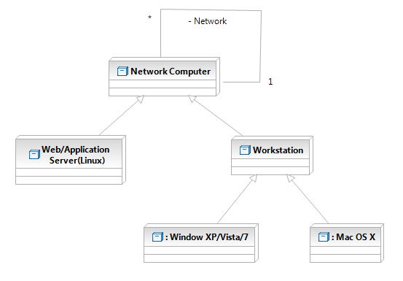
Figure 4: Hardware Component Course Diagram

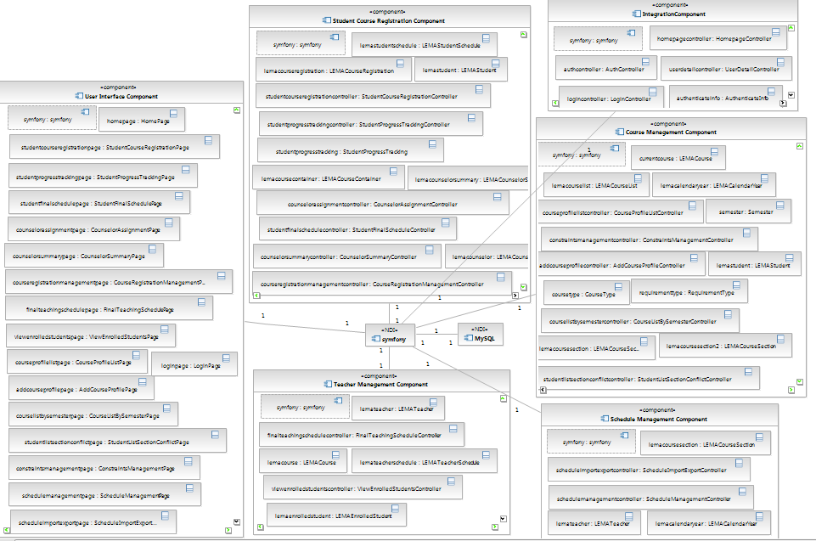
Figure 5: Software Component Course Diagram

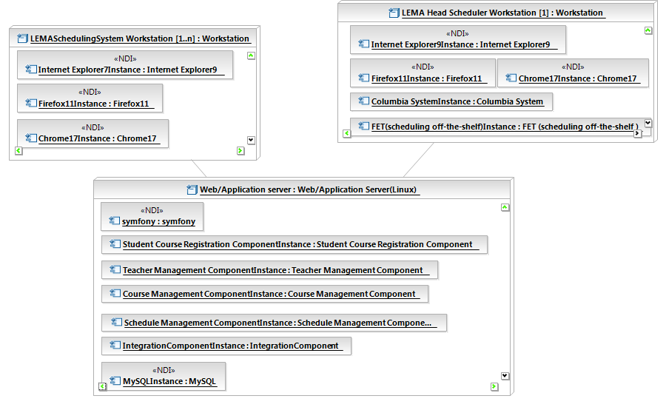
Figure 6: Deployment Diagram
Table 61: Hardware Component Description
Hardware Component | Description
Workstation | A workstation is the user's machine that the user connects to the Scheduling System over the Internet connection. The platform that the user uses is Microsoft Windows and the Mac OS with the internet browsers such as Firefox or Internet Explorer.
Web/Application Server(Linux) | A web server and the application server are on the same web hosting server. A web server accepts connections from the workstation and the Scheduling system's web application resides on the application server. The application server communicates with the web server and provides database accessibility and business logic.

Table 62: Software Component Description
Software Component | Description
User Interface Component | This component contains Scheduling System web pages for use by all Scheduling System user depending on their authentication. The primary component is the Student course allocation and Scheduling Management.
Student Course Registration Component | This component performs functions involved in allocating courses to students. Main functionalities are getting student course preference, providing student's available courses and showing student progress tracking
Teacher Management Component | This component contains that a scheduler allocate the teacher to the specific courses they can teach
Course Management Component | This component manage course information providing from the class constraints to the open class for this semester
Schedule Management Component | This component performs two different kinds of functionalities.  To provide teacher and course data to the scheduling COTS, this component support to export these data by creating CSV files. To get the final schedule from the Columbia system. it supports to import the final schedule into the database system.
Integration Component | This is for the integration part with the other CSCI577 team 4 developing the Family Accountability System.
Database Component | MySQL is used as a database to maintain the course and scheduling details for the project

Design Courses

Integration with the external system class
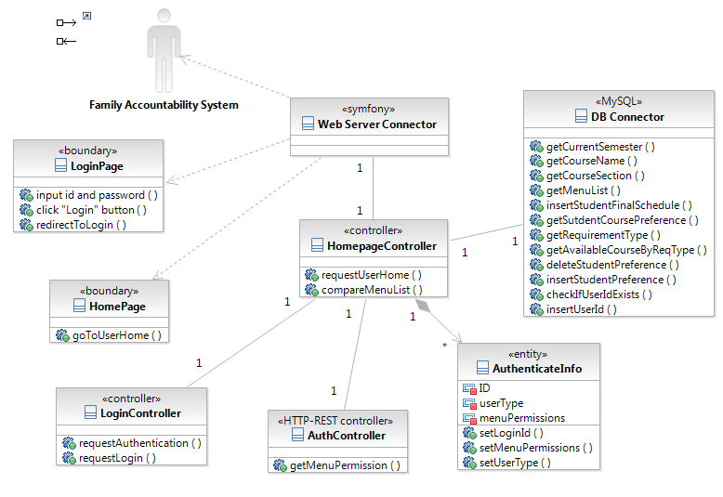
Figure 7: Integration with the external system Class Diagram

Table 63: Integration with the external system class diagram Description
Course | Type | Description
Family Accountability System | Actor | The external system integrating with our system. LoginController sends id and pass word to FAS and get return if the user is authenticated or not. We also get permitted menu list for the user type through REST API
AuthenticateInfo | Entity | contains user's id, type, permitted menu list
LoginPage | Entity | Getting id and password from the user
LoginController | controller | Request authentication to FAS. If it is successful, check user table and if we do not initiate that user, insert the id into the user table.
Homepage | boundary | Request HomepageController for the proper home page for the user and display it
HomepageController | controller | Request menu permission to FAS through REST and if the page is allowed to access then display the menu depending on the user menu permission
AuthController | HTTP-REST controller | Requests for the user's menu permission information to the Accountability System
DB Connector | MySQL Connector | Provides easier access to the Database

Student course preference class
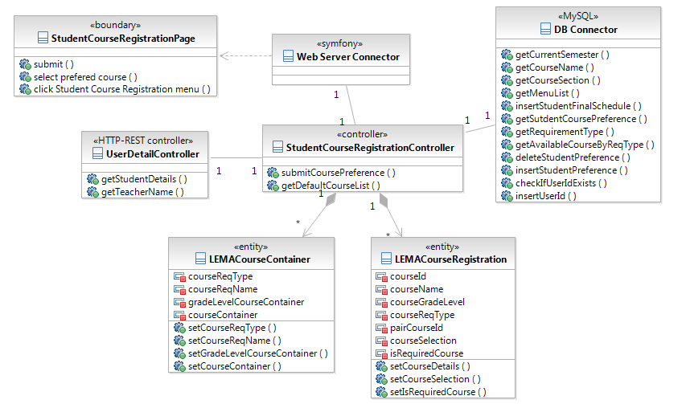
Figure 8: student course preference Class Diagram

Table 64: student course preference class diagram Description
Course | Type | Description
StudentCourseRegistrationPage | boundary | Contains student's default course lists and be able to submit student's course preference
DBConnector | MySQL Connector | Provides easier access to the Database
UserDetailController | HTTP-REST controller | Gets each user's detail data from the accountability system
StudentCourseRegistrationController | controller | Contains the logic how to display default course list for student to register and submit student’s course registration information
LEMACourseContainer | entity | Contains requirement type and name with the arrays of student’s grade level and optional course list
LEMACourseRegistration | entity | Contains the course information for default course list for the student

Schedule Management class
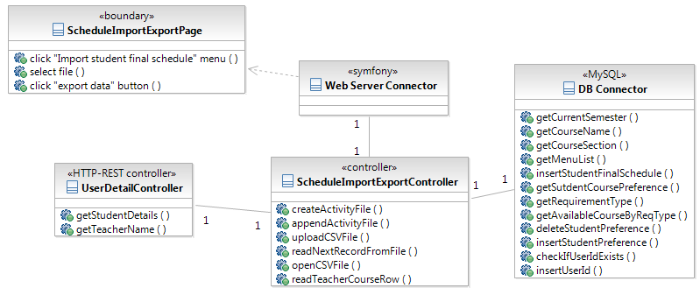
Figure 9: Export Activity Info & Import Final Schedule Class Diagram

Table 65: Export Activity Info & Import Final Schedule Class Diagram Description
Course | Type | Description
ScheduleImportExportPage | boundary | Contains schedule management menus such as export and import schedule or course information into or from our database
DBConnector | MySQL Connector | Provides easier access to the Database
UserDetailController | HTTP-REST controller | Gets each user's name data from the accountability system
ScheduleImportExportController | controller | Contains how to export data into activity CSV files to feed them into the FET application and the logic how to import the final schedule file into the database in the Scheduling System

Process Realization
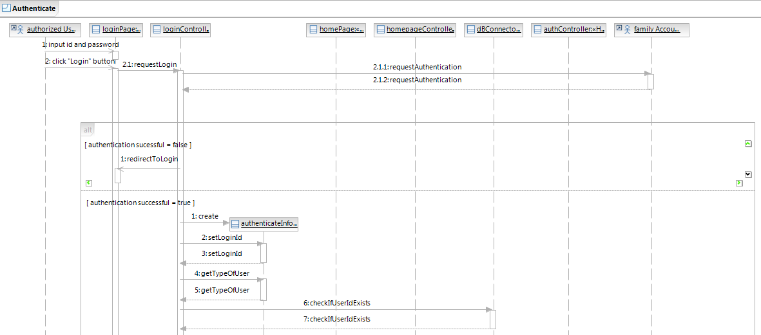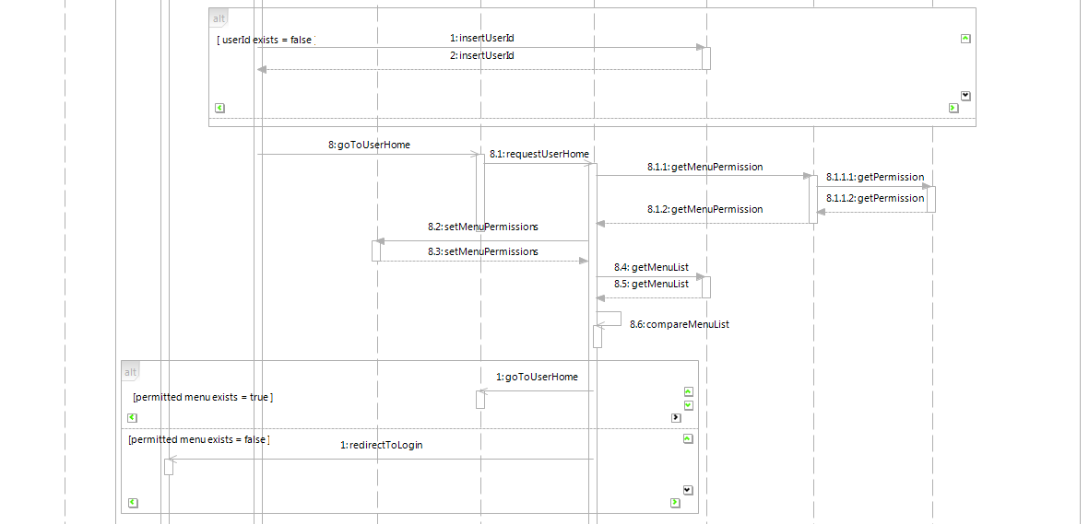
Figure 10: Authenticate Sequence Diagram

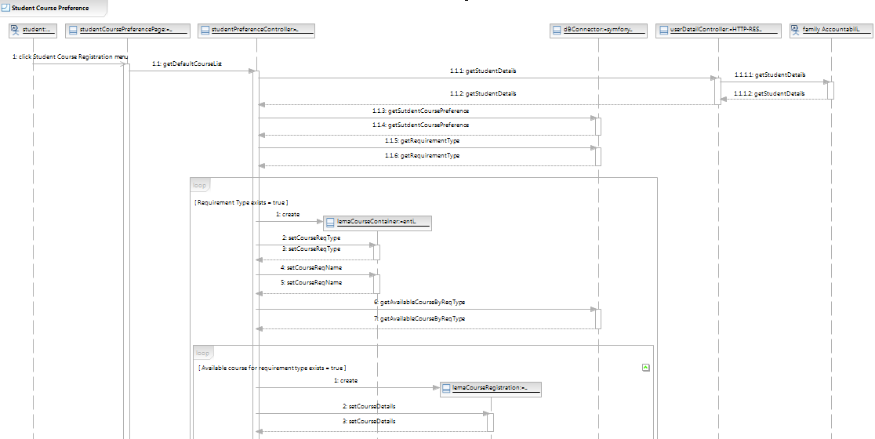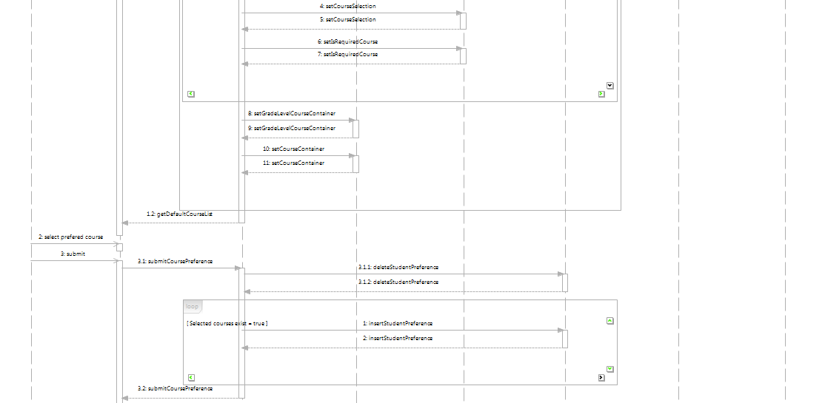
Figure 11: Student Course Preference Sequence Diagram
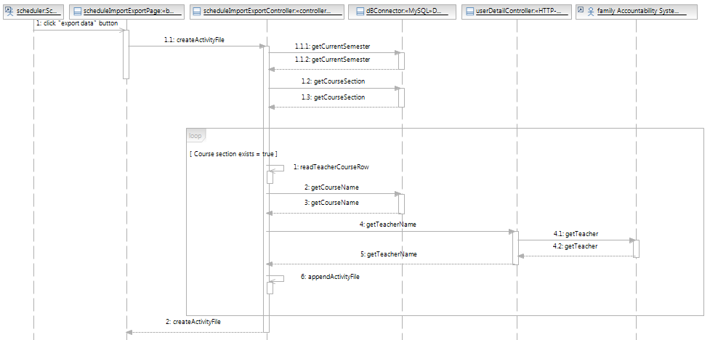
Figure 12: Export Activity Information Sequence Diagram
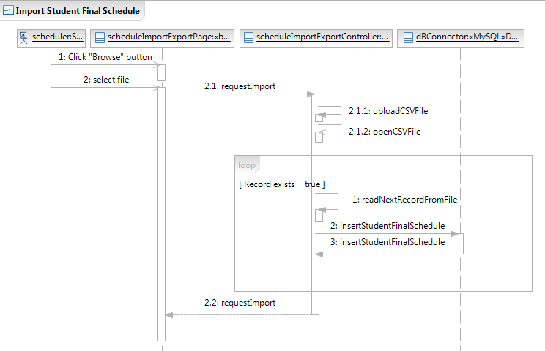
Figure 13: Import Student Final Schedule Sequence Diagram

Design Rationale

A user input id and password in LEMA Scheduling System, then get authentication result from FAS. If it fails, redirect to the log in page. If it is successful, check if the id exists in our database. If it is not initiated, insert id into the user table. The homepage displays the proper menu for the right user by comparing the permitted menu list between FAS and LEMA scheduling system database.

In the Student course preference, permitted student user click the menu and then the page gets the default course list by getting the student detail from the FAS first and then get each requirement type’s course list by grade level. After displaying the default course list, student selects preferred courses then the controller deletes the previous course preferences of the student and inserts selected course preference into database.

To export activity information from our database, a scheduler click activity export button on the webpage. Then the schedule management page requests creating the CSV file to the controller. The controller also gets the name of the courses from the database. The controller gets teachers id from the database and get teacher name through the REST controller from the FAS until there is no teacher data exists in our database. After getting teacher and course name, the controller appends the name to the activity CSV file. It creates the activity entity until there is no more course section information in the database.

In order to import student final schedule from the CSV file, a scheduler clicks the Import menu and the Schedule Import Export Page requests import to the controller. The controller reads record from the file and inserts them into the database row by row until it is the end of the file.

Architectural Styles, Patterns and Frameworks
Table 66: Architectural Styles, Patterns, and Frameworks
Name | Description | Benefits, Costs, and Limitations
Three-Tier Architecture(MVC) with Symfony | We will be defining Entity classes to separate Business logic from the Controllers.  - We followed MVC architectural pattern, but we implemented using MySQL connector instead of Data Doctrine provided in Symfony. | Separation of concerns and isolation of changes for a scalable environment and for development.
REST | Simple XML based on web services that can be produced and consumed without any dependencies on any languages or platforms | It can speak with other systems only such as the Family Accountability System that is required for sharing data.

